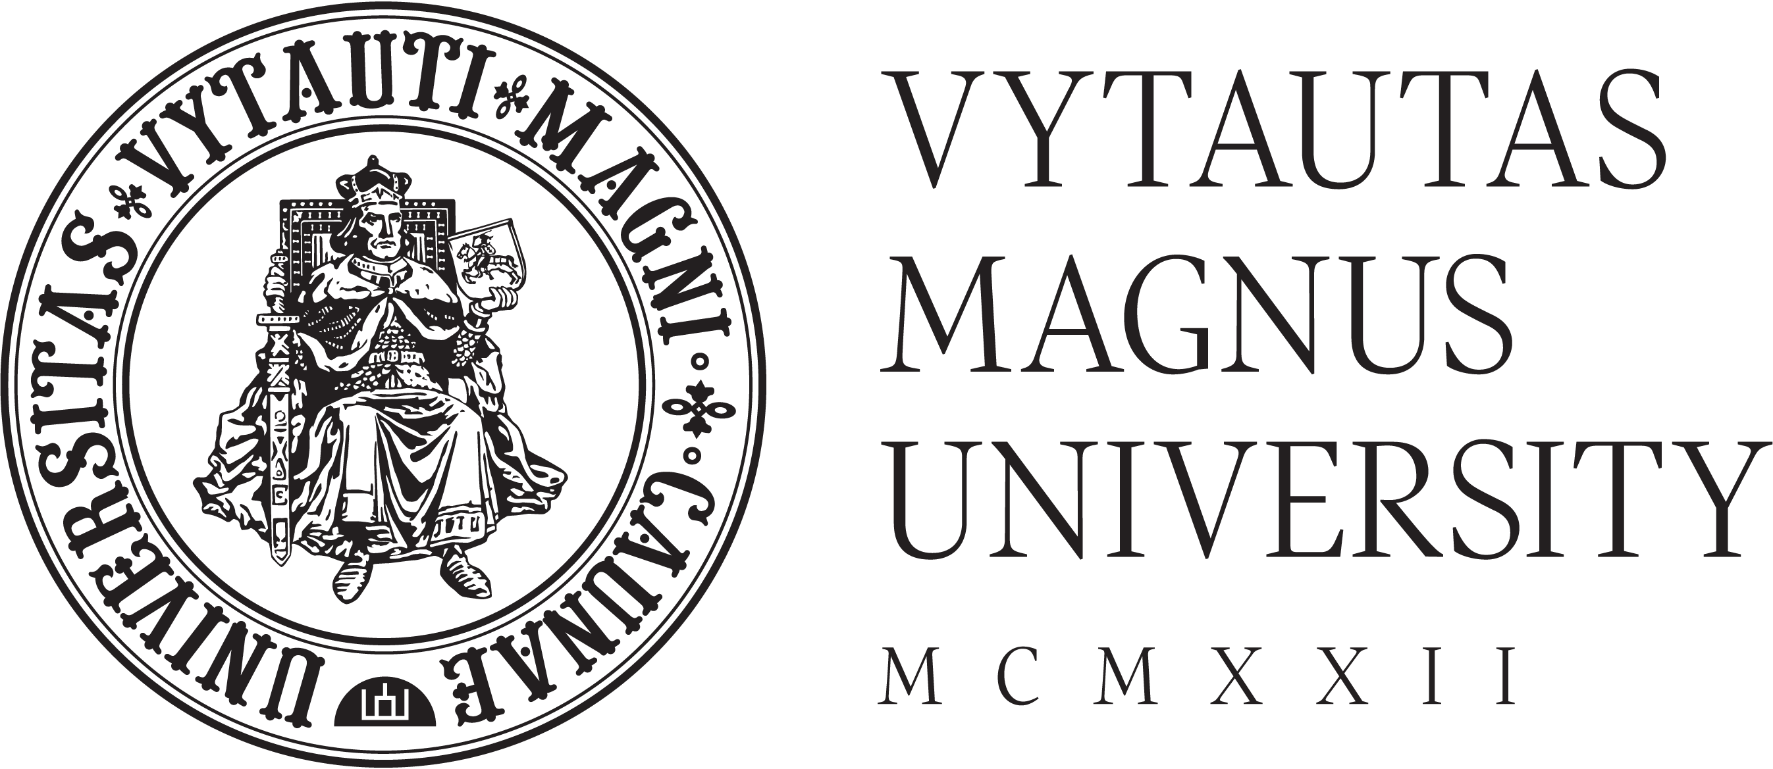

LETTER OF CONCURRENCE

dd/mm/yyyy

I, Name Surname, confirm that all the statements in the application form of Vytautas Magnus University are correct, truthful and complete.
I understand that provision of false information and/or submission of fraudulent documentation will influence my application and admission to Vytautas Magnus University and may be reported to the competent authorities.
Vytautas Magnus University has the right to send my educational documents to ENIC/NARIC Centre for Quality Assessment in Higher Education in Lithuania. ENIC/NARIC Centre is a special organization, set up by the national authorities, that evaluates all international students’ documents. It generally provides information on the recognition of diplomas, degrees and other qualifications and they are independent. It also evaluates the documents in general (they will see if you have access to higher education based on your previous education).
I give Vytautas Magnus University the permission to forward and receive my personal data to and from competent third parties (including, but not limiting to the awarding bodies, bodies administering the studies, authorities responsible for education and mobility, quality assurance agencies, etc.) for the purposes of gathering information necessary to make a decision regarding academic recognition of my qualification (concerning, but not limiting to verification of credentials, determination of the actual place and mode of study).

Name Surname
Signature

